Software documentation
WiFiLocator project
Group 5

I/ Mission and scope
1. Problem:
- Nowadays, Internet is provided in the waveform called “WiFi” more and more popular and people also can access the Internet by many portable devices such as smart phone or tablet. In the different places, the WiFi signal are dissimilar, so using the WiFi signal that these devices receive, people can determine the place they stay at.
2. Goal:
- This application can determine the WiFi information, create a database to save it and its related place. After that, these data is used to find the position where users stay at.
3. Scope:
- Our application is base on the Android platform. Every smart phone or tablet run this operation system can use this application.

II/ Requirement and specification
1. User's requirements
- Firstly, users want this application to show them all WiFi information such as WiFi name, SSID, last signal quality, average signal quality, detection counter, RSSI, channel frequency.
- Secondly, they want this application to have a feature of security.
- Additionally, this application need to have a function to save the WiFi information and its related place. After that, use the saved information to compare with the collected signal at a place.
- Finally, users want to have a guide to help them know how to use this application.
2. Specification
- Environment requirement: Android
III/ Project plan
1. Development team:
- Development team consists of: Ngo Minh Son (leader)
Chu Van Tao
Duong Duc Nam
Pham Tran Huong Giang.
2. The development and collaboration tools will be use:
- Programing Language: Android
- Main website: https://github.com/sonnm56/WiFiLocator
- Related website: https://www.pivotaltracker.com/s/projects/811263
- Checking tool: PMD, Android unit test.
- SQL database
3. Plan:
- The first demo we show the feature that collecting WiFi information.
- The second demo we create the security feature, the log-in log-out feature.
- The third time, we build a database to save the data, users can collect the WiFi information and save the place that relate this data.
- Checking plan: along with coding, we make test-class to check every function. After complete coding, we use PMD to improve the code.
IV/ Design
UML diagram
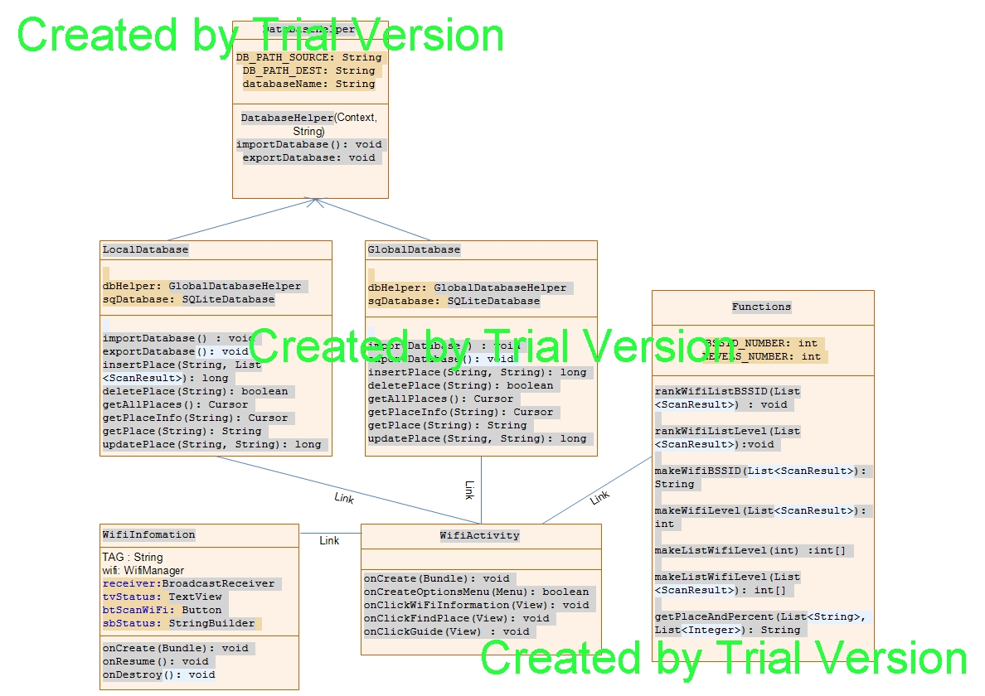
===

V/ How to use
- Security:
+ To use this application, you must type the pass and log in.
+ The initial pass is nothing
+ You can change pass word if you want (Press "Change pass word")

- WiFi Information:
+ You can see information of WiFi that your device receive
+ Press "Scan" to start

- Find Place:
+ You can see where you are when you go into this
+ Press "Find" to start find, and you will see: global place and local place

+ If you see "Not Found" maybe you are in new place, so you can press
"Add Place" to add new place.

+ Two buttons "Import" and "Export" to load and save the data.
+ So if you have already had data, press "Import" to copy data to application.
+ And you can export data of this application to file to share with "Export" button.
+ Note that you must create new folder named "MyFiles" in SD card before using
+"Import", "Export" buttons and if you have data, please copy to the "MyFiles".

